**## code CI-3**

class Request:

def __init__(self, client_id, request_id):

self.client_id = client_id

self.request_id = request_id

class Server:

def __init__(self, server_id):

self.server_id = server_id

self.current_load = 0

def handle_request(self, request):

self.current_load += 1

print(f"Server {self.server_id} handling request {request.request_id} from client {request.client_id}")

class LoadBalancer:

def __init__(self, servers, algorithm):

self.servers = servers

self.algorithm = algorithm

def distribute_request(self, request):

server = self.algorithm.choose_server(self.servers, request)

server.handle_request(request)

class RoundRobin:

def __init__(self):

self.current_index = 0

def choose_server(self, servers, request):

server = servers[self.current_index]

self.current_index = (self.current_index + 1) % len(servers)

return server

class RandomSelection:

def choose_server(self, servers, request):

return random.choice(servers)

servers = [Server(i) for i in range(5)]

requests = [Request(i, j) for i in range(10) for j in range(5)]

round_robin = RoundRobin()

load_balancer = LoadBalancer(servers, round_robin)

for request in requests:

load_balancer.distribute_request(request)

**## output**

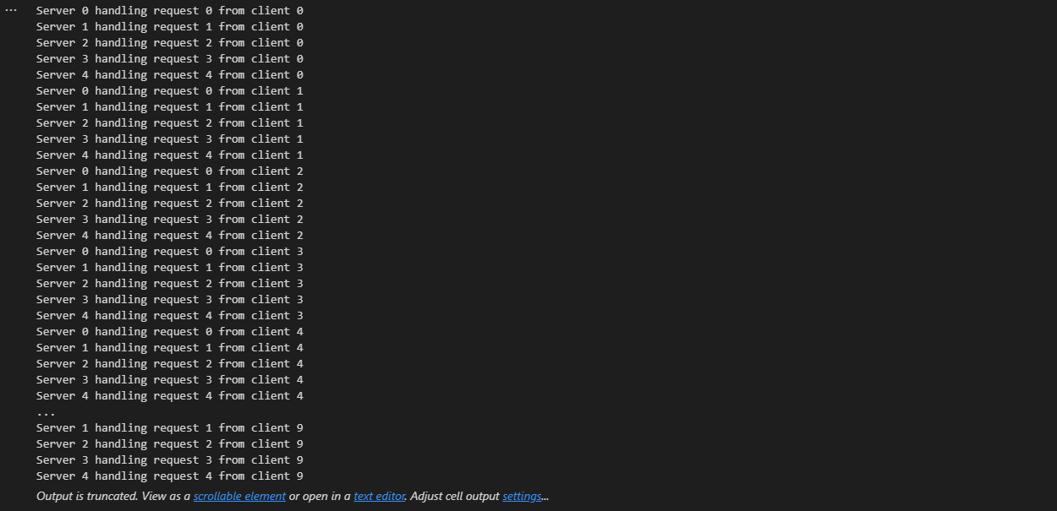

Server 0 handling request 0 from client 0

Server 1 handling request 1 from client 0

Server 2 handling request 2 from client 0

Server 3 handling request 3 from client 0

Server 4 handling request 4 from client 0

Server 0 handling request 0 from client 1

Server 1 handling request 1 from client 1

Server 2 handling request 2 from client 1

Server 3 handling request 3 from client 1

Server 4 handling request 4 from client 1

Server 0 handling request 0 from client 2

Server 1 handling request 1 from client 2

Server 2 handling request 2 from client 2

Server 3 handling request 3 from client 2

Server 4 handling request 4 from client 2

Server 0 handling request 0 from client 3

Server 1 handling request 1 from client 3

Server 2 handling request 2 from client 3

Server 3 handling request 3 from client 3

Server 4 handling request 4 from client 3

Server 0 handling request 0 from client 4

Server 1 handling request 1 from client 4

Server 2 handling request 2 from client 4

Server 3 handling request 3 from client 4

Server 4 handling request 4 from client 4

...

Server 1 handling request 1 from client 9

Server 2 handling request 2 from client 9

Server 3 handling request 3 from client 9

Server 4 handling request 4 from client 9